

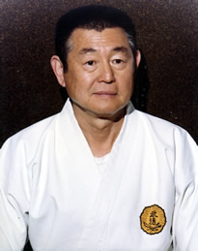 | As an artist uses different medium such as clay, paint or music, as a means of artistic impression a martial artist uses their own life as their mode of expression. (Kim 1988)  OSensei Richard Kim was such an artist. His completed artistic work, his life, went far beyond what most people could ever hope to imagine let alone accomplish. If the student must surpass the teacher in order to pay his debt to him then OSensei Richard Kim set the bar very, very high. He was a judo-ka, a boxer, a soldier, a karate master, a priest (video 2001), a Ph.D. in oriental philosophy (Warrener 1982: 65), a writer and lecturer, was able to speak six languages (Ricci, May 17, 2005) and was a martial arts sensei.

OSensei Richard Kim was born in Hawaii on November 17, 1919 (Warrener 1982: 91) of a Korean father and Japanese mother. His father was a landscaper and his mother owned a hotel (Ricci, May 4, 2005). The basement of the hotel was rented to a judo instructor named Tachi Bana. When OSensei Kim was six years old his mother enrolled him in judo classes (video 2001). | 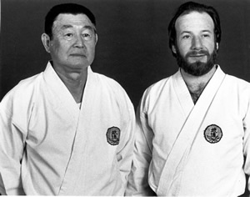
OSensei Richard Kim’s karate training began in 1927 (video 2001) with a man named Arakaki who was a disciple of Yabu Kentsu (Kim 1974: 3). Yabu Kentsu had been a student of two great Okinawan karate masters, Matusumura Sokon and Yasutsune Itosu. He was one of the first men to instruct martial arts in the Okinawan school system and was known as “the sergeant.” (McCarthy 1987: 32). Yabu Kentsu was returning to Okinawa after a visit to California and stopped over in Hawaii. He performed a demonstration at the Nuuanu YMCA on July 8, 1927 (Svinth 2001: 10, 14). OSensei Richard Kim witnessed the demonstration and afterwards started training in the Yabu Kentsu style of shorinji ryu (video 2001) Shorinji ryu is a style of karate, which is a synthesis of Okinawan and Japanese karate (Farkas, Corcoran 1983: 242). The young Richard Kim had been enticed by the movements that he saw in the demonstration. Later, in the 1930s, OSensei Kim met Yabu Kentsu again in Japan and continued his training with him there (Ricci, April 21, 2005). In 1933, while in Honolulu, OSensei Kim furthered his karate knowledge under the direction of a man named Tachibana (Kim 1974: 3).
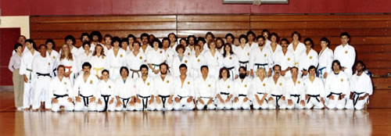
As a teenager “Biggie” Kim, as he was known, spent a great deal of time at local boxing clubs where he acquired his boxing skills while acting as a sparring partner for some of the top world contenders (Kim 1982: 6,7). He later explained what he learned most from boxing was the jab and focus. He also learned the limitations of boxing when he witnessed a lightweight hall of fame boxer driven head first into the floor by a Samoan wrestler (Ricci, April 21, 2005). OSensei Richard Kim would later have forty-two fights in the ring and became the champion of the Orient while living in Shanghai (Warrener 2001: 93).
After graduating from high school OSenesi Kim attended the University of Hawaii (Kim 1974: 3). During his time at the university he joined the Reserve Officers Training Corp and was made a captain in the ROTC (Ricci, April 21, 2005). Men who completed the Reserve Officers Training Corp training were given commissions in the US Army Reserve (University of Hawaii ROTC web site).
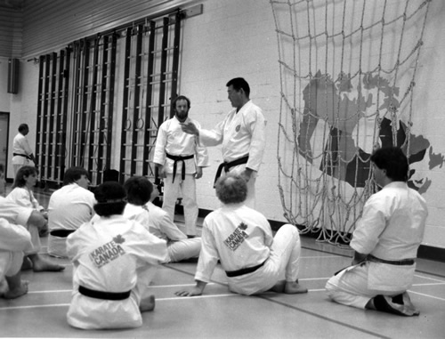
In 1939 (video 2001) Kim arranged to travel to Japan by working on a ship in lieu of payment. He was able to go to Japan because he had been born prior to The Exclusions Act of 1924 and held dual citizenship (Warrener 2001: 93). But upon arrival he had to “jump ship” as he was underage (Ricci, April 21, 2005). Once in Japan, OSensei Kim became a member of the Japanese military (Warrener 2001: 92).
Richard Kim continued his martial arts training while in Japan with Yoshida Kotaro, this time in daito ryu. (video 2001) Daito ryu was one of the most renowned of the old Japanese styles of combat and had been practiced by the warriors of the Minamoto clan for several centuries before being inherited by the Takeda family (Ratti and Westbrook 1973: 356). Kotaro had trained with Takeda Sokato a descendent of the Takeda family (video 2001)
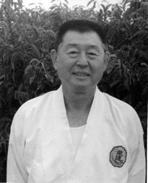 | Yoshida Kotaro was renowned for his weapon’s skills (Sells 2000: 135, 137) and was an expert with the yari (spear) and the halberd (Corcoran, Farkas, Sobel 1993: 396). The training with Yoshida Kotaro was very physical and very harsh. Kotaro taught throwing techniques and also worked with swords and knives. OSensei Richard Kim became an apprentice under Kotaro and eventually was given the menkyo kaiden for daito ryu (Warrener 2001: 92). A menkyo kaiden is a certificate of full proficiency that is usually awarded to an advanced student deemed most suited to carry on the transmission of the art (Farkas and Corcoran 1983: 177).

OSensei Richard Kim was then sent to China and worked as an interpreter for a Japanese army officer. (Ricci Dec.12, 2005) But his martial arts training continued. Chen Chin Wuan taught him a slightly modified version of Yang style tai chi chuan. He learned paqua with Chao Hsu Lie whom he met while in Hong Kong. OSensei Kim also trained in chi kung with Wan Tsing Zie. His first lesson was to stand in a chi kung posture known as “embrace the tree” for a total of three hours a day (video 2001). On the academic side, while living in Shanghai OSensei Kim attended St. John’s University (Kim 1982: 6,7).  After World War II Richard Kim owned and operated a bar in Yokohama, Japan. Mas Oyama1 and Kinjo Hiroshi2 would come by his house once a week to train. He later met Gogen Yamaguchi3 through Oyama (video 2001). As well during this same time OSensei Richard Kim represented the Seaman’s Union in Yokohama (Kim 1999). | 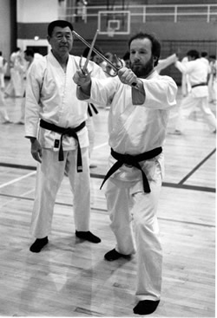
In 1959 OSensei Kim moved back to the USA and made a permanent residence in San Francisco, California (Kim 1974: 3). He conducted a martial arts program at the Chinese YMCA until his semi-retirement in 1978 (Corcoran, Farkas and Sobel 1993: 339). Over the years OSensei Richard Kim traveled all over the world teaching the martial arts and creating a large international organization with schools in the US, Canada and Europe. He called his organization the Zen Bei ButokuKai4.
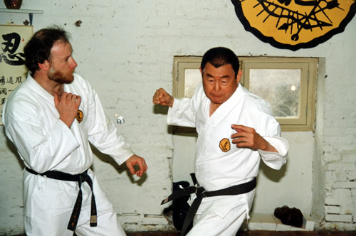
In 2000 OSensei Kim was awarded a tenth degree black belt from the Hawaii Karate Kodanshakai (Goodin 2005). In the same year at a gathering held in a Chinese restaurant in Sacramento OSensei Kim told the group that he had awarded his long time student, Brian Ricci, a seventh dan. That was the only time he had conferred the rank on anyone. It was also the highest rank he had ever given (Ricci, May 22, 2005).
OSensei Kim did not attend the annual Zen Bei Butokukai 2001 summer camp held at Guelph University in Ontario because of his health. He arranged for Sensei Brian Ricci to run the camp in his absence. At a black belt meeting on the first evening of the summer camp Sensei Ricci explained that he expected that some day OSensei Kim would not be able to teach but had hoped it would not have been so soon. Sensei Ricci made it clear to the black belts in attendance that he had been put in charge of the camp and he intended to fulfill that responsibility to his sensei.
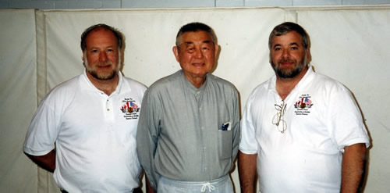
OSensei Richard Kim died on November 8, 2001 and Sensei Brian Ricci has continued his teacher’s work in propagating the martial arts. The majority of OSensei Richard Kim’s students now train with Sensei Brian Ricci. The Zen Bei ButokuKai International summer camp at Guelph University continues to be held every year and has grown under the care of Sensei Brian Ricci and Sensei Frank Gaviola with students from all over North America attending.

No one ever will replace OSensei Richard Kim. The circumstances of his life gave him the opportunity to train in a number of martial arts in the countries where they had originated during a turbulent time in history. His personal development was a result of his amazing work ethic. OSensei Kim once said, “If you sleep more than four hours a day you lose.”  Today, years after his death, the students of OSensei Kim are faced with the daunting task of passing on the teachings of their instructor. Their loyalty and devotion guarantee OSensei Kim’s knowledge and wisdom will continue into the next generation. And that generation is sure to view the stories of this great man’s life as legend. | 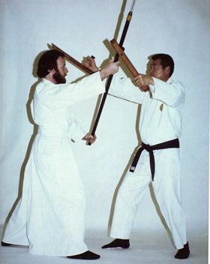
The author would like to thank Sensei Brian Ricci for providing some of the photographs used in this article. A special thank you to both Sensei Ricci and Sensei Frank Gaviola for their help and suggestions with the article.
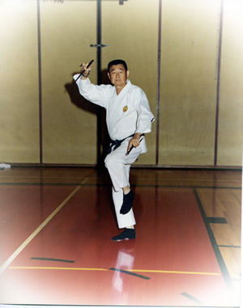 | The author would especially like to thank O'Sensei Richard Kim for his guidance.  The complete version of this article is available in the Journal of Asian Martial Arts, Volume 15, Number 1. This version, entitled, “The Legacy of Dr. Richard Kim: An Interview with Brian Ricci”, gives a more complete life story section, an interview with Sensei Brian Ricci, and a technical section on the bo.  We would like to thank Mike DeMarco of the Journal of Asian Martial Arts and Sensei Robert Toth, the author, for allowing us to use this portion of their article.  Visit www.goviamedia.com for more information about the Journal of Asian Martial Arts and this article.
Click here for references...



